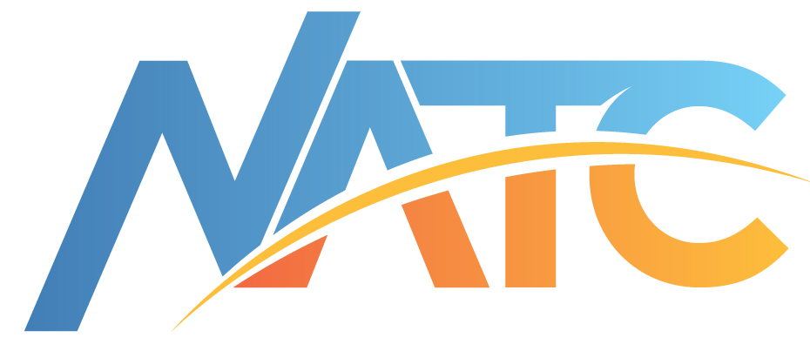 Successful production of a new car, truck, bus, or piece of support equipment depends on teamwork in order to meet customer expectations. The Nevada Automotive Test Center (NATC) has spent over 60 years developing partnerships with our customers. Our divisions are dedicated to providing value-added technical solutions to the worldwide transportation industry.
PARTNERS

Nevada Automotive Test Center
A Division of Hodges Transportation, Inc.

www.natc-ht.com

Headquarters Facility
P.O. Box 234
Carson City, NV 89702-0234
Phone: (775) 629-2000
Fax: (775) 629-2029
Email: info@natc-ht.com

Virginia Facility
Phone: (540) 657-7112

Our engineering and test services include translation of client needs into validated performance requirements. NATC develops North American and international user duty cycle profiles that are used to evaluate vehicle and component capabilities. NATC duplicates user conditions in controlled accelerated tests that incorporate extreme environmental (high temperature, low temperature, corrosion, etc.) cycles as well as representative road roughness inputs to provide a validated accelerated life cycle test. Fully instrumented vehicle evaluations are conducted at NATC including ride quality, heating/ ventilation/air conditioning (HVAC), stability, handling, and powertrain performance. NATC offers a full range of computer aided engineering (CAE) capabilities including full vehicle dynamic modeling/simulation, control systems modeling and integration, finite element analysis (FEA) with fatigue prediction capability, and computer aided drafting (CAD). Along with worldwide duty cycles, data acquisition, and advanced engineering analysis, NATC provides complete prototype fabrication capabilities for one-stop solutions from design to -product verification. Utilizing simulation tools including ADAMS, MATLAB, MSC Nastran, Dytran, Patran, PTC Creo, CEI EnSight, and FEA codes, NATC provides rapid design or corrective action development.


NATC’s division in Northern Virginia provides engineering services, and our dedicated winter test facility near West Yellowstone, Montana provides seasonal vehicle and component evaluations.

WesTrack
Phone: (775) 629-2000
Email: info@natc-ht.com

WesTrack
Phone: (775) 629-2000
Email: info@natc-ht.com

PIONEERING

NATC’s 1.8-mile WesTrack facility, funded by the Federal Highway Administration, was established to evaluate experimental asphalt pavement designs, accelerated test and measurement systems, and tire pavement interface characteristics. This facility incorporated fully autonomous 150,000 pound commercial tractor trailer operations (over 900,000 miles) and serves as a platform for validation of new autonomous vehicle systems. Utilizing the technology developed in house for these driverless vehicles, NATC provides vehicle health monitoring systems that allow non-intrusive measurement of vehicles in fleet or customer service.


Our dedicated fabrication facility is equipped and staffed to provide complete prototype fabrication and modification for all types of ground vehicle systems. Our team has developed and delivered specialized test equipment including mobile dynamometers, environmental test chambers, and fully instrumented vehicles. We have built advanced vehicle prototypes incorporating state of the art technologies required for success in the new millennium.

Working with our customers, our solutions have been integrated into thousands of vehicle systems. We can provide cost effective value added solutions for you.
Real Time, Real World Solutions™

